**34 Развертывание Windows-приложений**

Задание 1. Возьмите за основы проект Windows Forms и создайте установочный файл Setup.msi изучив Теоретический материал.

Листинг программы:

<?xml version="1.0" encoding="UTF-8"?>

<Wix xmlns="http://schemas.microsoft.com/wix/2006/wi">

<?define ProductName="Tema34SetupProject"?>

<?define ProductVersion="1.0.0.0"?>

<?define ProductCode="69e26e59-2adb-45d4-a0b0-693333305fa5"?>

<?define UpgradeCode="06a81104-7c9b-4b9f-9b3b-7c9b4b9f9b3b"?>

<?define Manufacturer="Eroshkevich"?>

<Product Id="$(var.ProductCode)" Name="$(var.ProductName)" Language="1049" Version="$(var.ProductVersion)" Manufacturer="$(var.Manufacturer)" UpgradeCode="$(var.UpgradeCode)">

<Package InstallerVersion="200" Compressed="yes" InstallScope="perMachine" />

<MajorUpgrade DowngradeErrorMessage="A newer version of [ProductName] is already installed." />

<MediaTemplate />

<Feature Id="ProductFeature" Title="Task1SetupProject" Level="1">

<ComponentRef Id="CalcApplication"/>

<ComponentRef Id="CalcApplicationShortCut"/>

</Feature>

<Property Id="WIXUI_INSTALLDIR" Value="INSTALLFOLDER"/>

<WixVariable Id="WixUILicenseRtf" Overridable="yes" Value='D:\Projects\C#\Practice_CSharp\Tema34\LIC.rtf'/>

<UIRef Id="WixUI_InstallDir"/>

</Product>

<Fragment>

<Directory Id="TARGETDIR" Name="SourceDir">

<Directory Id="ProgramFilesFolder">

<Directory Id="INSTALLFOLDER" Name="$(var.ProductName)" />

</Directory>

<Directory Id="ProgramMenuFolder">

<Directory Id="ApplicationProgramsFolder" Name="$(var.ProductName)">

<Component Id="CalcApplicationShortCut" Guid="b11552d1-6f4f-4d0d-9b6e-9b6e9b6e9b6e">

<Shortcut Id="ShortCutDBP" Name="DatabaseProgram" Description="$(var.ProductName)" Target="[INSTALLFOLDER]\Task1.exe" WorkingDirectory="INSTALLFOLDER"/>

<RemoveFolder Id="ApplicationProgramsFolder" On="uninstall"/>

<RegistryValue Root="HKCU" Key="Software\$(var.Manufacturer)\$(var.ProductName)" Name="installed" Type="integer" Value="1" KeyPath="yes"/>

</Component>

</Directory>

</Directory>

</Directory>

</Fragment>

<Fragment>

<ComponentGroup Id="ProductComponents" Directory="INSTALLFOLDER">

<Component Id="CalcApplication" Guid="b11556d1-6f4f-4d0d-9b6e-9b6e9b6e9b6e">

<File Id="CalcApplication" DiskId="1" Source='D:\Projects\C#\Practice_CSharp\Tema34\Calc.exe'/>

</Component>

</ComponentGroup>

</Fragment>

</Wix>

Таблица 34.1 – Входные и выходные данные

|  |  |
| --- | --- |
| Входные данные | Выходные данные |
|  |  |

Анализ результатов:

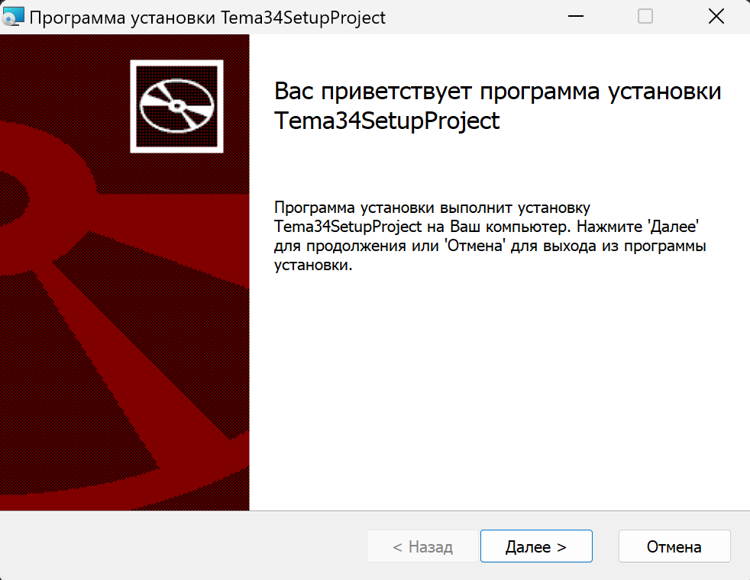

Рисунок 34.1 – Результат работы программы